How much does digital advertising accelerate new product success?
Giacomo Bertozzi
Saeed Bagheri
Brett Graham
Peter Knowles
Oded Netzer
Koen Pauwels

How much does digital advertising accelerate new product success?
ABSTRACT
Many new products are launched in ecommerce. While advertising is believed to enhance new product success, managers often lack the numbers to quantify this benefit to the firm. Retail websites offer specific success benchmarks, such as pre-purchase product views, purchase conversion and post-purchase reviews. This paper’s main thesis is that, while new products can succeed with or without advertising, digital advertising can help products achieve success faster. Across five categories, this research shows that digital advertising on Amazon.com can cut the time needed to reach success levels by more than half, compared to products that reach these same benchmarks without such advertising.

INTRODUCTION
Advertising has long been considered an important contributor to new product success, as it helps prospective customers learn about the new product and entices them to purchase it¹. Unfortunately, marketing managers often lack hard metrics to convince their financial backers (such as the internal finance department or external investors) that the investment is worth it². The easy availability of “earned” media channels such as online customer reviews has complicated the case for paid media channels such as advertising, as companies tend to cut back on ad spending, believing earned media can serve as a free substitute for paid media³. However, this availability of online data also allows advertisers to measure how advertising helps the success of a new product. Having access to retail website data, commonly observed by sellers and advertisers through retailers such as Amazon allow advertisers to measure pre-purchase metrics such as product views, sales metrics such as conversation rates, and post-purchase metrics such as the number of reviews the product receives over time. These metrics allow us to assess the speed by which a product succeeded and how digital advertising may have affected the product success.
Traditionally the ‘purchase funnel’ was measured using surveys. Retail websites have not only changed the ‘consumer journey’ by adding steps to it (e.g., post purchase online reviews), but has also given us unobtrusive and real-time measures of aggregate customer activity⁴. This paper leverages these new metrics to quantify the extent to which advertising, in this case advertising on Amazon, can reduce the time it takes new products to reach key success benchmarks. Managers can use these insights not only to measure and predict new product success, but also to justify the needed budgets to support new products with advertising. To the best of our knowledge, no previous paper has looked at the impact of advertising on both pre- and post-purchase ecommerce metrics.
Digital advertising is typically evaluated primarily based on in its short-term success of ad-exposed shoppers converting to buyers (performance marketing). For instance, most online advertisers evaluate the effectiveness of a campaign at the return on the advertising spend (ROAS). The ROAS of a campaign is measured as the number of ad-attributed sales divided by the budget spend. While this metric has its benefits for purchase conversion of established products, it likely underestimates the advertising benefits for newly launched products. The objective of this paper is to assess to what extent digital advertising helps to enhance new product success and quantify its effect on the measures of the steps within the online customer journey.
This paper proposes and tests new benchmarks to evaluate advertising’s impact on new product success for pre-purchase product views, purchase conversion and post-purchase reviews. We compare the time it takes new products to reach these benchmarks depending on whether they are supported or not by digital advertising at the retailer (Amazon). To create a comparable “control” group for advertised new products, we compare advertised new products to products that were non-advertised, in the same price tier and with the same star ratings. Additionally, all control group products reached our new product success benchmarks, thus eliminating new product failure and providing a strong control group. Compared to non-advertised new products, advertised new products reach top-100 viewed product status in the category, mean purchase conversion in the category and 15 reviews, respectively 53%, 38% and 23% faster.

2. RESEARCH BACKGROUND
Product success depends on many factors related to product value and its fit with customer needs. In addition, several papers in marketing literature show that advertising can be effective in improving the likelihood of success of new products and hence in increasing firm value⁴. However, most of this evidence comes primarily from traditional marketing methods and does not specifically study digital marketing channels⁵. Retail websites provides additional metrics to evaluate whether advertising is moving pre-purchase metrics, such as visits to the product’s webpage⁶, purchase metrics, such as view-to-sales conversion⁷, and post-purchase metrics such as online reviews⁸. However, brand managers lack milestones to put these metrics into perspective, e.g., is a view-to-sales conversion of 2% for my new product in line with the category’s benchmark? This makes it harder for them to measure whether the advertising is moving the new product. Moreover, the effect of advertising on new product success is not well understood. Brand managers often lack examples of quantified benefits of advertising new products, and so are frequently unable to demonstrate to financial executives that this can provide the company with faster and more reliable cash flows⁹.
The timing of new product take-off is of key importance to brand managers of consumer durables to demonstrate the likely long-term return on the considerable investment their companies spend on new product launch¹⁰. Advertising is believed to accelerate this timing, but quantitative evaluation is typically lacking, making it harder to specify the payback time of the financial investment. This payback time is even more important in today’s fast-paced digital world where cycles of diffusion are often shorter¹¹. Fortunately, retail websites also yield new metrics to help pinpoint how advertising accelerates a new product’s success. First, product page views yield a valuable proxy for the pre-purchase interest by prospective customers¹². The purchase conversion of these views to orders translates this interest to action. Last but not least, online word-of-mouth has a strong influence on prospective customers, even more so for retail websites than on social media sites¹³. Customers read reviews to reduce the risk associated with a purchase decision, and a higher number of online reviews thus increases new product success¹⁴. Product reviews have been demonstrated to be associated with higher sales⁸. Moreover, the impact of reviews likely depends on the average product rating (a proxy for product quality) and the product’s selling price (a proxy for the financial risk associated with the purchase). Indeed, analysis of two retail websites reveals a higher purchase probability when there are more reviews and the product is higher priced¹⁴.
In sum, previous research has been scant on quantifying how much digital advertising can accelerate new product success. Retail websites offer an opportunity not only to measure the effect of digital advertising on new product adoption but also on different stages in the product adoption funnel (pre-purchase, sale conversion and post purchase evaluations). To the best of our knowledge, this is the first paper to quantify how digital advertising accelerates pre-purchase, purchase and post-purchase metrics of new product success.
3. ECOMMERCE NEW PRODUCT SUCCESS METRICS
This paper aims to quantify by how much Amazon advertising can accelerate the success of a newly launched product on Amazon.com. Our main thesis is that, while new products can succeed with or without advertising, digital advertising can help products achieve success faster. In order to evaluate the performance of a product after launch, we focus on three success measures representing pre-purchase, purchase and post-purchase stages.
First, a pre-purchase page visit indicates the shopper is aware and at least somewhat interested in the new product. Scoring high in the number of page visits therefore indicates the new product has achieved a level of contextual interest in its category⁶. Amazon provides in its bestseller list the first 100 products by sales in each category. To evaluate the top performers for traffic, we applied the same standard and measure the time it takes a product to reach the top 100 position in terms of product page views in its category. In the categories studied, the 100th position in terms of page views reflects a product that is at the top 1% percentage of products in the category. Our access to the entire purchase journey on Amazon allows us to observe this important pre-purchase metric.
Second, going down the purchase funnel, we observe purchase conversion, which is defined as the proportion of customer who viewed the product page and ended up buying the product. This measure reflects that product page traffic converts into sales. Success in terms of conversion is measured as the time it takes a product to reach the weekly average conversion rate of the category. As shown in our analysis, new products that reach this average category rate, with or without advertising support, are able to sustain purchase conversion in the future, thus creating substantial cash flows for the company. Reaching the category conversion rate indicates that a new product has reached a “mature” conversion. The weekly conversion rate is calculated by dividing the ordered units by product page views. For robustness against outliers and supply-side factors, we apply two conditions for sample selection: 1) the new product reached at least 100 product page visits, and 2) the new product had an out-of-stock rate of below 5% in the weeks before they reach the category conversion rate. Out-of-stock rate is defined as the number of visits the product page receives where Amazon has no stock to sell, divided by the total number of visits to the product page. The first condition is needed to clean-up the data from early spike in conversion rate due to few product page views and few shipped units. The second condition is needed to compare products with similar low out-of-stock rate products, thus ruling out such supply-side issues as an alternative explanation for the results of the analysis.
Finally, the post-purchase metric is the number of product reviews submitted by customers. Success in this area is measured by looking at the time it takes for a product to reach 15 reviews on Amazon. The number 15 is important on Amazon because it is the minimum number of reviews a product needs to have in order for its review count and star rating to be shown in a banner on an Amazon display advertising campaign.

4 DATA: Sample and control group
We obtained data on page views, sales and product reviews for 73 new products launches in five product categories: two from electronics (Durable Category 1, 2) and 3 from consumables categories (Consumable Category 1, 2, 3) in Amazon’s U.S. store. The five categories were chosen because they had multiple product introductions (supported and not supported by advertising) during the data period (January 2018 and December 2018). A new product launch is defined as product that appeared for the first time in Amazon’s U.S. store. We excluded the launches of new colors or size version of existing products since those are usually displayed in the same page of the original version and therefore can be found by looking for the existing product. Of the 73 new product launches, we compare the launch of 47 products supported by Amazon advertising, to 26 comparable products (similar price and average star rating) not supported by Amazon advertising.
We constructed our sample of advertised products based on the following criteria:
- The product was launched in Amazon’s U.S. store between January and December 2018.
- The products were supported by an advertising campaign within 90 days of the launch of the product (the median and mean of number of days in our sample is 43).
- The advertising campaign supporting the product launch generated at least 450 detail page views attributed to a click on a banner. (Median page views is 3,707, mean is 8,156).
- In the 365 days post launch, all the products studied had met the following performance benchmarks: 1) Reach the top 100 products rank in the subcategory in terms of product page views products, 2) Reach average subcategory purchase conversion, and 3) Obtain 15 customer reviews.
The control group consisted of the 26 products that met all following conditions:
- The products belong to the same five categories, are launched in the same period and have a similar price and star rating.
- In the 365 days post launch, all the products in the control group had met the following performance benchmarks: 1) Top 100 rank in the subcategory in terms of product page views products, 2) Reached average subcategory purchase conversion, and 3) Obtained 15 customer reviews.
- Control group products receive less than 450 detail page views attributed to a click on a banner in the first 90 days post launch. (Median: 0, Mean: 13).
Table 1 below compares the advertised and the control new products in terms of their average selling price (ASP) and average star rating (rating out of 5 stars) in each category. Interestingly, the control group of non-advertised products has a slightly lower rating than advertised products for Durable Category 2, Consumable Category 1, but a higher average rating for the other 3 categories: Durable Category 1, Consumable Category 2 and Consumable Category 3. However, none of these differences are statistically significant, as t-tests did not reject the null hypothesis of same selling price and review rating between the two groups in each of the studied categories.

Table 1: Average selling price and star rating for advertised versus control group products
Variable Name | Average Selling Price (ASP) |  |  | Average Star Rating (Rating)
Category | Advertised group | Control group | p-value of difference | Advertised group | Control group | p-value of difference
Durable Category 1 (n=15) | 1267.761 | 1129.213 | 0.897 | 3.853 | 4.194 | 0.469
Durable Category 2 (n=13) | 575.583 | 649.295 | 0.561 | 4.004 | 3.940 | 0.120
Consumable Category 1 (n=8) | 49.807 | 51.614 | 0.450 | 4.265 | 4.013 | 0.304
Consumable Category 2 (n=26) | 23.135 | 20.841 | 0.459 | 4.132 | 4.269 | 0.410
Consumable Category 3 (n=11) | 14.886 | 13.584 | 0.422 | 4.497 | 4.616 | 0.873
Total (Average) | 368.297 | 376.922 | 0.946 | 4.120 | 4.215 | 0.366

The total estimated budget invested in the advertised group in the first 90 days is $9.8MM, the average invested by product is $209K, median $89k. On average, the allocation of advertising budget is split 55% for upper funnel campaigns (e.g., display advertising) and 45% for lower-funnel campaigns (e.g., Sponsored Products). The time between launch and advertising campaign start for the studied products ranged between 1 and 81 days, with an average first ad attributed details page view occurring 43 days post launch. On average, within the first 90 days from the launch, the studied new products received 8.1k detail page views attributed to a click on an ad (median 3k).

5 RESULTS
We show in Figure 1 the daily average score for the advertised versus the control group of products from launch in the first 8 months post launch for each success criterion, respectively product page view (traffic) rank, purchase conversion and cumulative number of reviews. Note that both advertised and control groups reach the milestone (indicated by the horizontal line in the figure), but at different times.
Figure 1: Evolution of launch success dimensions for advertised vs control group products.
- Evolution of the average rank by product page visit.
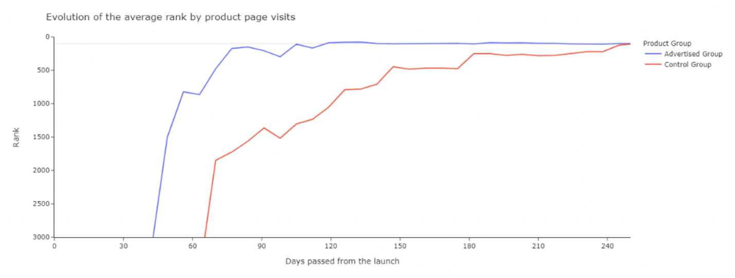
- Evolution of the average conversion rate.
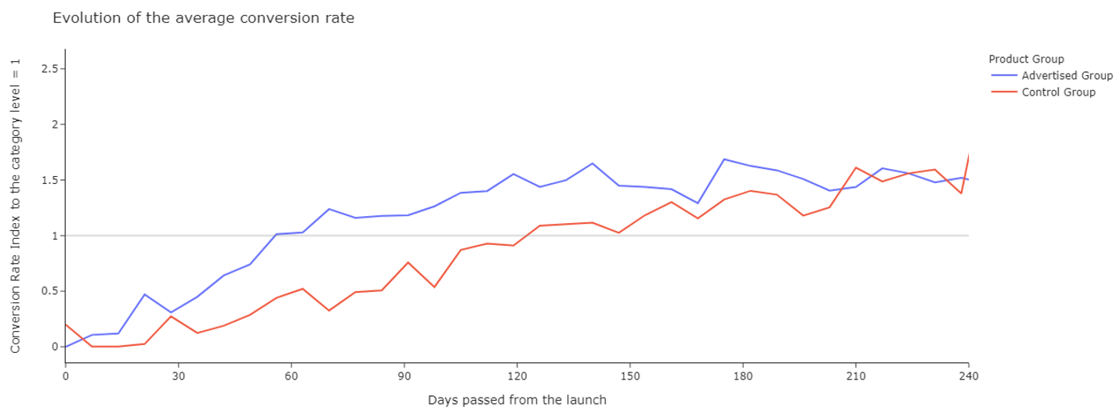
- Evolution of the number of reviews.
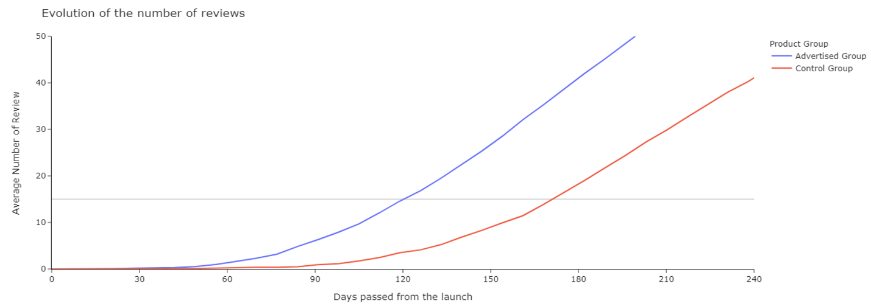
The advertised products soon start outperforming products in the control group in pre-purchase and purchase metrics, and after 45 days in the post-purchase metric of consumers’ reviews. The control group catches up in both page rank and average purchase conversion (Figures 1a,b) but advertised products continue to enjoy more reviews (Figure 1c).
We observe a similar pattern for sales rank in Figure 2: advertised products start with a higher sales rank and continue to outperform non-advertised products in the following months, but the control group does catch up in sales rank after about 8 months.
Figure 2: Evolution of sales rank for advertised vs control group products
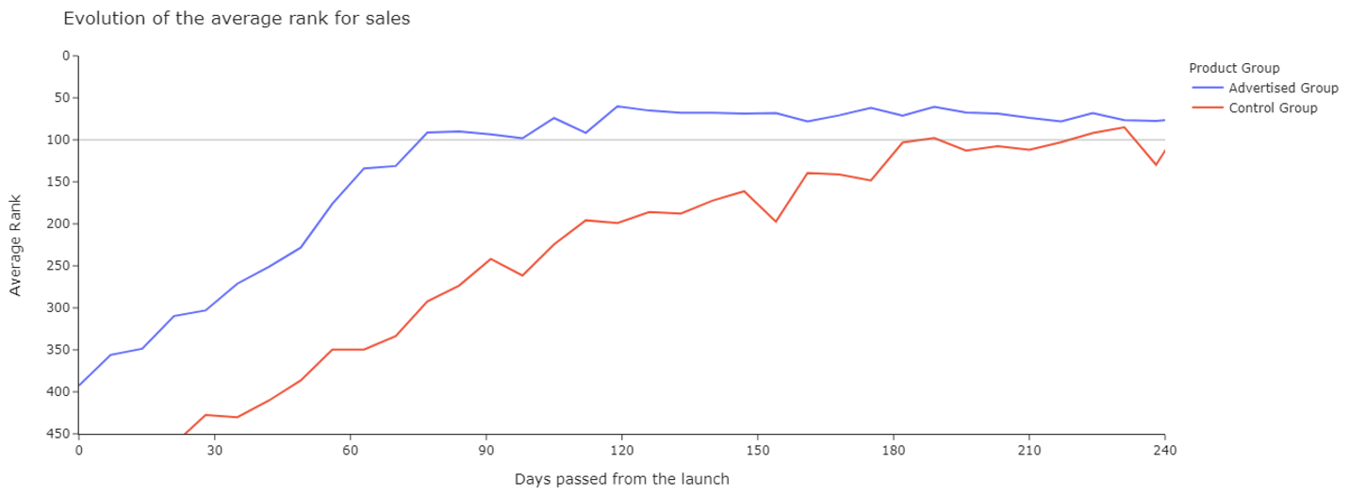
In order to test whether the difference in time-to-milestone is statistically significant, we need to evaluate the two groups at specific benchmarks. To this end, we compare the time it took new products that were supported by advertising and those that were not to reach the success measures. We show in Figure 3 the boxplot of the distribution of the two groups for the time in days to: reach the top 100th rank product page views (left panel), reach average category purchase conversion (middle panel), and reach 15 reviews (right panel).

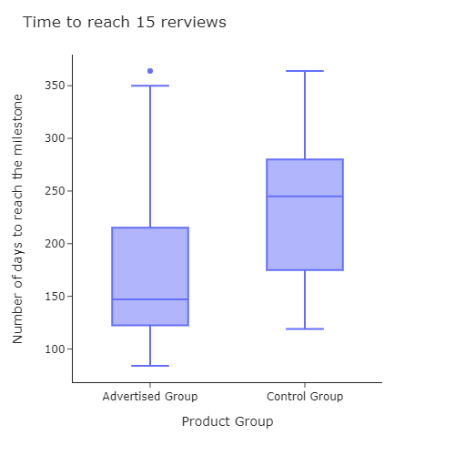
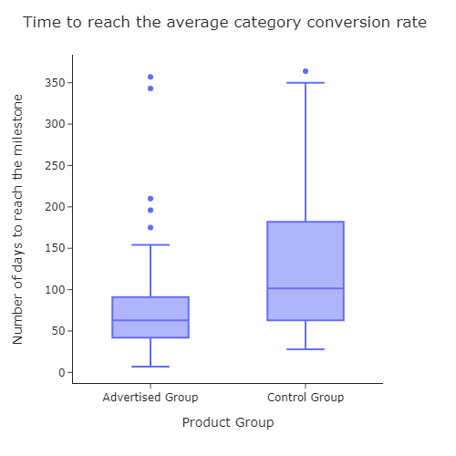
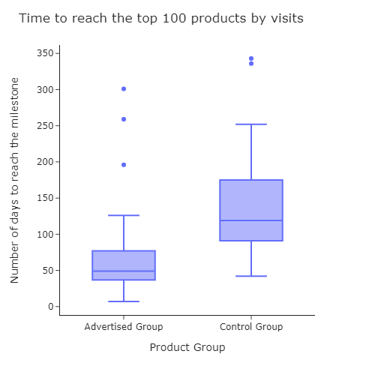
Figure 3: Boxplot of advertised vs control group products’ days to reach each milestone
The figures show that, for all three success measures, new product supported by Amazon advertising: (1) On average achieved the milestone earlier than new products that were not supported by advertising (control), and (2) Showed a lower variance in the time to reach each success. Due to the different variances, we use the ANOVA Welch test to verify whether the difference in the times taken to reach the success metrics are significantly different at the 95% confidence level¹⁵. Recall that both advertised and control new products all reached the milestone in less than one year post launch. This was done to maintain comparability and to avoid the possibility that a few outliers could significantly change the overall sample mean.
The results of the ANOVA and Welch tests compare the mean of the advertised versus control group (Table 2). The results show statistically significant differences across all three success metrics with p-value less than 0.03.

Table 2: Mean overall days of reaching each milestone in advertised versus control group
Variable | Advertised | Control group | t-value (P-value)
Days reaching 100 top products by traffic | 68.063 | 143.769 | 0.0001***
Days reaching category conversion rate | 84.297 | 135.961 | 0.0225**
Days reaching 15 reviews | 176.787 | 231.0 | 0.002***
Days reaching top 100 rank in weekly sales | 62.851 | 116.038 | 0.0005***
** significant at the 95% confidence level, *** significant at the 99% confidence level
Our overall results also apply to each of the studied categories, as visualized in Figure 4 for sales rank.

Figure 4: Boxplot of advertised vs control group’s days to reach top 100 sales rank
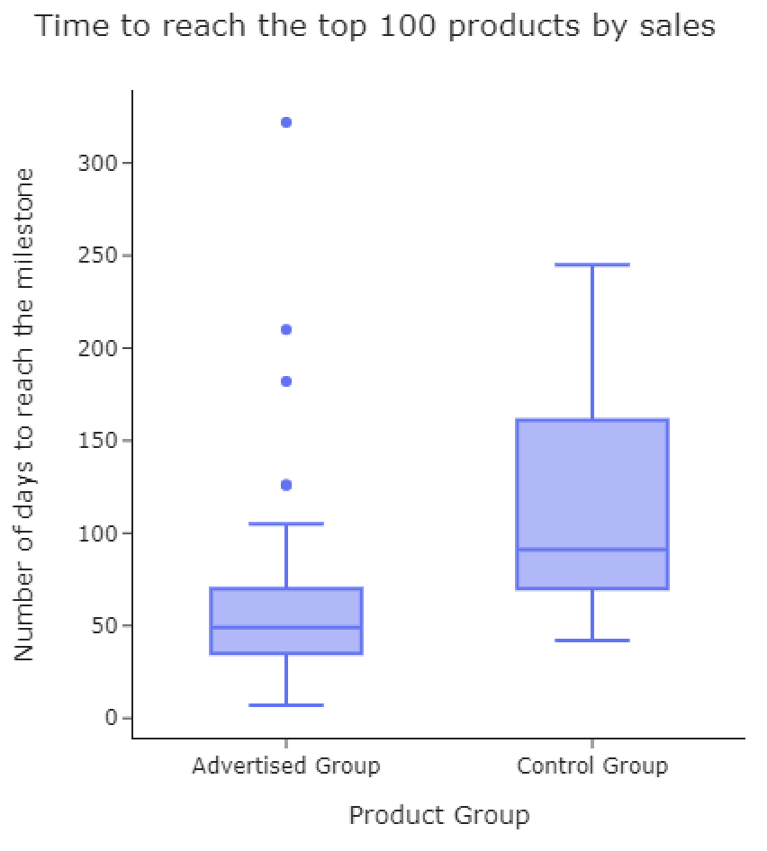
While the category sample size is often too small for the difference to be statistically significant (e.g. only 8 studied products for Consumable Category 1), the direction of the difference is consistent across the very different product categories. Durable Category 2, Consumable Category 3 and Consumable Category 2 particularly benefitted from advertising, with the average time to reach the top 100 sales cut by at least half.

6. DISCUSSION
Our study shows that, while advertising is not necessary for new product success, supporting new product launches on Amazon with on-site advertising can accelerate the time it took new products to reach success levels across consumer durable categories. While we do not know of a similar timing analysis in other contexts, this paper adds to the extensive literature that advertising benefits new product success⁴. To the best of our knowledge, this study is the first to quantity such advertising acceleration benefits on pre-purchase, purchase and post-purchase metrics. We also contribute to the literature on the effect of advertising on the purchase funnel. Our access to a unique dataset that includes observation of the entire funnel from page view, to conversion of pageviews to sales, to post-purchase ratings allows us to assess the effect of advertising on each these purchase funnel metrics, going beyond the typically used metric of sales. We believe that previous research has been limited by the availability of data focusing on the available data in exploring upper funnel metrics such page views and page view conversion.
We provide a specific benchmark of a new product joining the top 100 viewed products in its category. This concrete number is easy to track (versus e.g., the top 1%), and our findings hold up for top 50 (and top 200) lists, so managers can adjust their desired success goal based on the information provided to them. As to purchase conversion, the average conversion rate in the category is a valuable benchmark, as it indicates the new product has ‘joined the ranks’ of the existing products. With respect to customer online reviews, previous research¹⁴ analyzed retailers with more limited assortments (a unique, high-priced product and a health-and-beauty retailer) and less reviews per product (5+ reviews was the highest number of reviews category).

7. Practical implications and Suggestions for Future Research
This paper contributes to existing evidence that advertising helps new product success by quantifying the impact of advertising on observable metrics. In particular, the empirical analysis shows that advertising support can significantly accelerate the new product reaching key success metrics in Amazon’s store. We demonstrate this advertising benefit compared to a strong control group: new products that still reached the performance benchmarks, but were not supported by Amazon advertising. We show this power of advertising even in the context of online customer reviews, which are therefore not substitutes for advertising³.
Moreover, advertisers can and should replicate this analysis to demonstrate the value of their own launch campaigns. The analysis of how much faster their product grew versus a benchmark of the top performing product in the subcategory could become a new narrative which could complement ROAS in an analysis of ad campaign performance. In this way, showing a more complete picture of the value of advertising product managers could better convince their finance leadership to keep investing in their future product launches at retail websites that track these benchmarked metrics.
Finally, since the aim of this paper was to get an overall first assessment of the impact of advertising on product launches, this paper simplified the number of variables studied. Further research could define what would be the best media mix in terms of channel, amount, duration and landing page. Further research should also be conducted to study how different variables outside advertising could impact the overall product launch such as early retail promotions, Vine reviews, off-Amazon activities.
Advertising provides support for new products. This research helps brands managers make its financial case by quantifying how much it can accelerate new product success metrics. It also provides valuable information regarding how advertising reduces the uncertainty in time taken to reach new product success benchmarks. This is important for marketers as it can help provide better parameters against which they can judge the extent to which their new product launches are successful in terms of achieving benchmarks in a timely fashion. Using advertising to reduce uncertainty in time to achieve product success may also be valuable to advertisers planning more complex, sequential launches, where it is desirable for consumers to accept a particular new product before they are exposed to another, different, but related new product. Laundry detergent product launches that aim to change consumer habits in a specific, stepwise sequence, by, for example, reducing suds gradually to encourage consumers to rely less on sudsing as a signal of efficacy, could be an example of a multi-step product launch scenario where uncertainty in time to reach consumer acceptance is important. We hope this can inspire brands to experiment with adding new advertising channels to their portfolio and to better support their new product launches.
References:
¹ Lavidge, Robert J. and Gary A. Steiner (1961), “A model for predictive measurements of advertising effectiveness”, Journal of Marketing, 25 (October), 59-62.
² Wind, Y. J., & Sharp, B. (2009). Advertising empirical generalizations: Implications for research and action. Journal of Advertising Research, 49(2), 246-252.
³ Hollenbeck, B., Moorthy, S., & Proserpio, D. (2019). Advertising strategy in the presence of reviews: An empirical analysis. Marketing Science, 38(5), 793-811.
⁴ Srinivasan, S., K. Pauwels, J. Silva-Risso, and D. M. Hanssens. "Product innovations, advertising, and stock returns." Journal of Marketing 73, no. 1 (2009): 24-43.
⁵ Kireyev, P., Pauwels, K., & Gupta, S. (2016). Do display ads influence search? Attribution and dynamics in online advertising. International Journal of Research in Marketing, 33(3), 475-490.
⁶ Pauwels, K., and B. van Ewijk. "Enduring Attitudes and Contextual Interest: When and Why Attitude Surveys Still Matter in the Online Consumer Decision Journey." Journal of Interactive Marketing 52 (2020): 20-34.
⁷ De Haan, E., Wiesel, T., & Pauwels, K. (2016). The effectiveness of different forms of online advertising for purchase conversion in a multiple-channel attribution framework. International Journal of Research in Marketing, 33(3), 491-507.
⁸ Schoenmueller, V., O. Netzer, and F. Stahl. "The Polarity of Online Reviews: Prevalence, Drivers and Implications." Journal of Marketing Research 57, no. 5 (2020): 853-877.
⁹ Hanssens, D. M., & Pauwels, K. H. (2016). Demonstrating the value of marketing. Journal of Marketing, 80(6), 173-190.
¹⁰ Golder, P. N., & Tellis, G. J. (1997). Will it ever fly? Modeling the takeoff of really new consumer durables. Marketing Science, 16 (3), 256-270.
¹¹ Layugan, S. (2020), “How to plan a new product launch with digital marketing”, ThomasNet, June 30, https://blog.thomasnet.com/how-to-plan-a-new-product-launch-with-digital-marketing
¹² Moe, W. W. (2003). Buying, searching, or browsing: Differentiating between online shoppers using in-store navigational clickstream. Journal of Consumer Psychology, 13(1-2), 29-39.
13 Babić Rosario, A., Sotgiu, F., De Valck, K., & Bijmolt, T. H. (2016). The effect of electronic word of mouth on sales: A meta-analytic review of platform, product, and metric factors. Journal of Marketing Research, 53(3), 297-318.
14 Maslowska, E., Malthouse, E. C., & Viswanathan, V. (2017). Do customer reviews drive purchase decisions? The moderating roles of review exposure and price. Decision Support Systems, 98, 1-9.
¹⁵ Welch, B. L. (1947). The generalization of Student's problem when several different population variances are involved. Biometrika, 34, 28-35.

Analytics and Media Manager, Amazon Advertising, Email: bertozzi at amazon.it. The authors acknowledge the help of Amazon Advertising.
We conducted a robustness check for the 50th and 200th position in terms of page views and obtain consistent results. Results are available from the authors.
For this count, we exclude the reviews coming from the Vine Program, where Amazon invites the most trusted reviewers on Amazon to post opinions about new and pre-release items by shipping free products that have been submitted to the program by participating vendors.
As to the ad type, 51% of the products were promoted with both Sponsored ads and Display, 49% only with Sponsored ads in the first 90 days.
Note that the averages displayed in Figure 1 and Figure 3 show different information. Figure 1 shows the average metric value for the two group in a specific week. It’s an average of the metric value. Figure 3 shows the average week when the products reach the milestone. It’s therefore an average of time. The average in Figure 3 cannot be compared to the time when the line in Figure 1 crosses the milestone because the line in Figure 1 crosses the milestone when the entire group average is above the milestone and this does not match the average of the first time the individual products cross the milestone.

